Plot Histogram Assignment

1. We have v <- c(19, 23, 11, 5, 16, 21, 32,14, 19, 27, 39)

Use C data to plot histogram as the following:

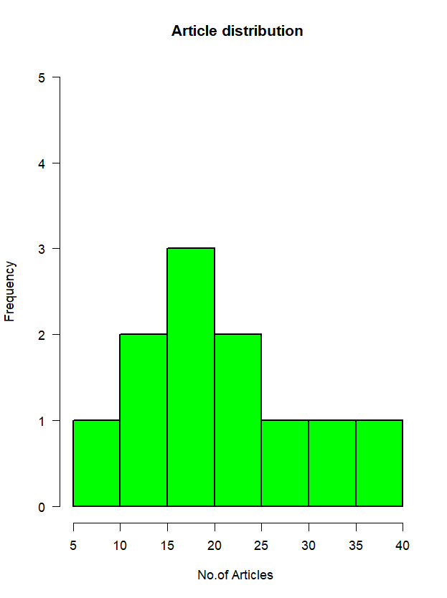

Write your code:

1. You have a weight data:

weight <- c(19, 23, 11, 5, 16, 21, 32, 14, 19, 27, 39, 120, 40, 70, 90)

Plot histogram of the weight to get the pic as follow:

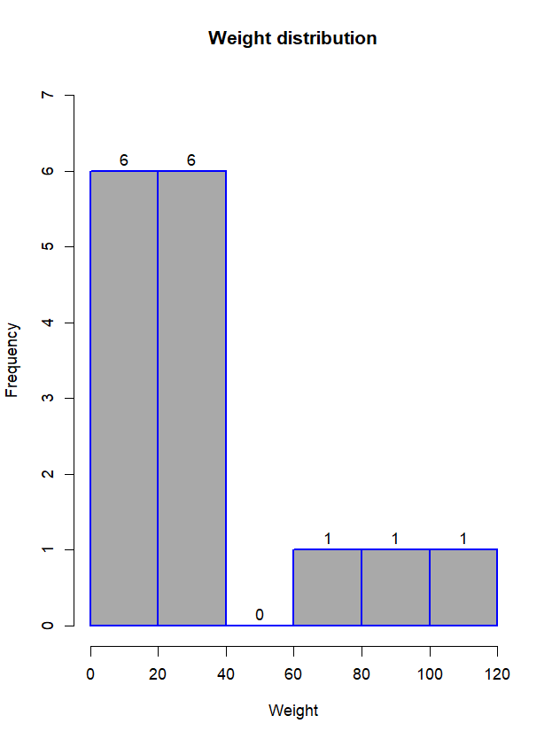

Write your code:

1. You have data of weight as follow:

weight <- c(19, 23, 11, 5, 16, 21, 32, 14, 19, 27, 39,40,23,60, 120, 40, 70, 90)

write the code to Plot histogram of the weight data as follow:

